**CS-7611**

**COMPILER DESIGN LABORATORY**

**PROJECT ABSTRACT**

**TOPIC: CONTENT SIMILARITY CHECKER FOR SENTENCES**

**TEAM MEMBERS:**

**TEJAS RAMESH RAMESH-2017103070**

**PAVITHRA KARTHY-2017103059**

**OVERVIEW / PROBLEM STATEMENT**

The measurement of sentence similarity plays a very important role in text-related research and applications such as web page retrieval, text mining and dialogue systems. The methods currently existing for computing sentence similarity have been adopted from approaches used for long text documents, wherein they process sentences in a very high-dimensional space; these consequently inefficient, require human input, hence are not adaptable to some domains.

The aim of this project is to compute the similarity between very short texts of sentence length. It takes account of semantic information and word order information from the sentences.

Here in this project, we aim to develop a base for determining the measure of semantic similarity between 2 words, phrases or sentences and generate graph structure which displays their relationship.

Existing techniques for detecting similarity between long texts such as documents, have centered on analyzing shared words. These methods are usually effective while dealing with long texts because similar long texts will usually contain a degree of co-occurring words. Whereas in short texts, word co-occurrence may be rare or sometimes even null. This is primarily due to the inherent flexibility of natural language enabling people to express similar meanings using quite different sentences in terms of structure and word content.

Since such information in short texts is limited, this problem poses a difficult computational challenge. The focus of this project is on computing the similarity between very short texts, primarily of sentence length.

For a pair of sentences, T 1 and T 2 , that contain exactly the same words in the same order with the exception of two words from T 1 which occur in the reverse order in T 2 . For example:

. T 1 : A quick brown dog jumps over the lazy fox.

. T 2 : A quick brown fox jumps over the lazy dog.

As both the sentences contain the same words, any method based on a “bag of words” will give a decision that T 1 and T 2 are exactly the same. However, it is clear for a human that T 1 and T 2 are only similar to a certain extent. The dissimilarity between T 1 and T 2 is the result of the different word order. Therefore, a computational method for sentence similarity should take into account the impact of word order.

For the example pair of sentences T 1 and T 2 , the joint word set is:

T ={A quick brown dog jumps over the lazy fox}

While semantic similarity represents the lexical similarity, word order similarity provides information about the relationship between the words: which words appear in the sentence and which words come before or after other words. Both semantic and syntactic information plays an important role in conveying the meaning of sentences.

Thus the overall sentence similarity is defined as a combination of word order similarity and semantic similarity.

**TOOLS USED TO DEVELOP CODE:**

**LINUX/TERMINAL IMPLEMENTATION**

**Operating system: LINUX (Ubuntu v.18.04)**

Ubuntu is a free and open-source Linux distribution based on Debian. Ubuntu is officially released in three editions: Desktop, Server, and Core for the internet of things devices and robots. All the editions can run on the computer alone, or in a virtual machine.

**Lex tool:**

Lex is a computer program that generates lexical analyzers ("scanners" or "lexers").

Lex is commonly used with the yacc parser generator. Lex,Lex reads an input stream specifying the lexical analyzer and outputs source code implementing the lexer in the C programming language. In addition to C, some old versions of Lex could also generate a lexer in Ratfor.

**Yacc Tool:Yacc (Yet Another Compiler-Compiler)**

It is a computer program for the Unix operating system developed by Stephen C. Johnson. It is a Look Ahead Left-to-Right (LALR) parser generator, generating a parser, the part of a compiler that tries to make syntactic sense of the source code, specifically a LALR parser, based on an analytic grammar written in a notation similar to Backus–Naur Form (BNF).Yacc is supplied as a standard utility on BSD and AT&T Unix. GNU-based Linux distributions include Bison, a forward-compatible Yacc replacement.

**PYTHON IMPLEMENTATION**

**Jupyter Notebook**:Project Jupyter is a nonprofit organization created to "develop open-source software, open-standards, and services for interactive computing across dozens of programming languages". Spun-off from IPython in 2014 by Fernando Pérez, Project Jupyter supports execution environments in several dozen languages.

**Notepad**:To give text file inputs in the format (.txt)

**NLTK(Natural language Toolkit):**The Natural Language Toolkit, or more commonly NLTK, is a suite of libraries and programs for symbolic and statistical natural language processing for English written in the Python programming language.

**IMPLEMENTATION DETAILS AND SAMPLE OUTPUTS.**

**FLOW OF THE PROJECT IN LINUX/TERMINAL IMPLEMENTATION:**

**1.Compile the lex code (project30703059.l) using the command:**

lex project30703059.l

**2.Compile the yacc code (project30703059.y) Using the command:**

yacc project30703059.y

gcc y.tab.c -ll -ly

**You will receive some warnings,but that is okay as it won’t hinder the working of the code.**

**3.Run the program using the command:**

./a.out

**4.Upon entering the program you will receive instructions on how to execute the code.**

**WELCOME TO THE SENTENCE SIMILARITY CHECKER**

**PLEASE NOTE: ENTER THE STRINGS IN THE FOLLOWING MANNER:**

**EXAMPLE:The quick brown fox .**

**END1(###to view entered 1st string and its length###)**

**The quick brown dog .**

**END2(###to view entered 2nd string and its length###)**

**ENTER THE SIZE OF THE FIRST STRING**

**ENTER THE SIZE OF THE SECOND STRING**

**Enter the details as per user’s wish**

**(PLEASE NOTE: FOR DISSIMILAR SENTENCE LENGTHS THE PROGRAMS OUTPUT IS:)**

**“STRINGS ARE DIFFERENT**

**DISSIMILAR CONTENT!!!!**

**EXAMPLE IF USER’S INPUT IS:**

**ENTER THE SIZE OF THE FIRST STRING 10**

**ENTER THE SIZE OF THE SECOND STRING 9**

**Whatever the input after this step the output is:**

**“STRINGS ARE DIFFERENT**

**DISSIMILAR CONTENT!!!!**

**After entering the sizes of the sentences and hitting enter:**

**User must enter the first sentence:**

**Example: The quick brown fox .**

**Followed by:**

**END1-(“END1”:DISPLAYS THE FIRST SENTENCE WHICH IS STORED IN A LINKED LIST)**

**SIMILARLY,**

**User must enter the second sentence:**

**Example: The quick brown dog .**

**Followed by:**

**END2-(“END2”:DISPLAYS THE SECOND SENTENCE WHICH IS STORED IN A LINKED LIST)**

**After entering both sentences:**

**User must type:**

**COMPARE-(“COMPARE”:runs the main logical part of the program to give the user the results-1.Subset of words in 1st sentence,2.Subset of words in the 2nd sentence,3.Total set of words in both sentences.)**

**After this Output is obtained:**

**1.Directly if content is similar.**

**2.By pressing Ctrl+D if the content is different.**

**FLOW OF THE PROJECT IN PYTHON (JUPYTER NOTEBOOK) IMPLEMENTATION:**

**1.Just download the .ipynb file and run it on jupyter notebook**

**SAMPLE OUTPUT SNAPSHOTS NEXT PAGE ONWARDS**

**( PLEASE NOTE:THE LEX AND YACC FILES IN THE SNAPSHOT HAVE BEEN RENAMED FOR PROJECT SUBMISSION AND EVALUATION PURPOSES.)**

**GITHUB REPOSITORY LINK FOR THIS PROJECT.**

[**https://github.com/tejas3070/CompilerLabProject**](https://github.com/tejas3070/CompilerLabProject)

**SAMPLE OUTPUT SNAPSHOTS** **(LINUX/TERMINAL IMPLEMENTATION)**

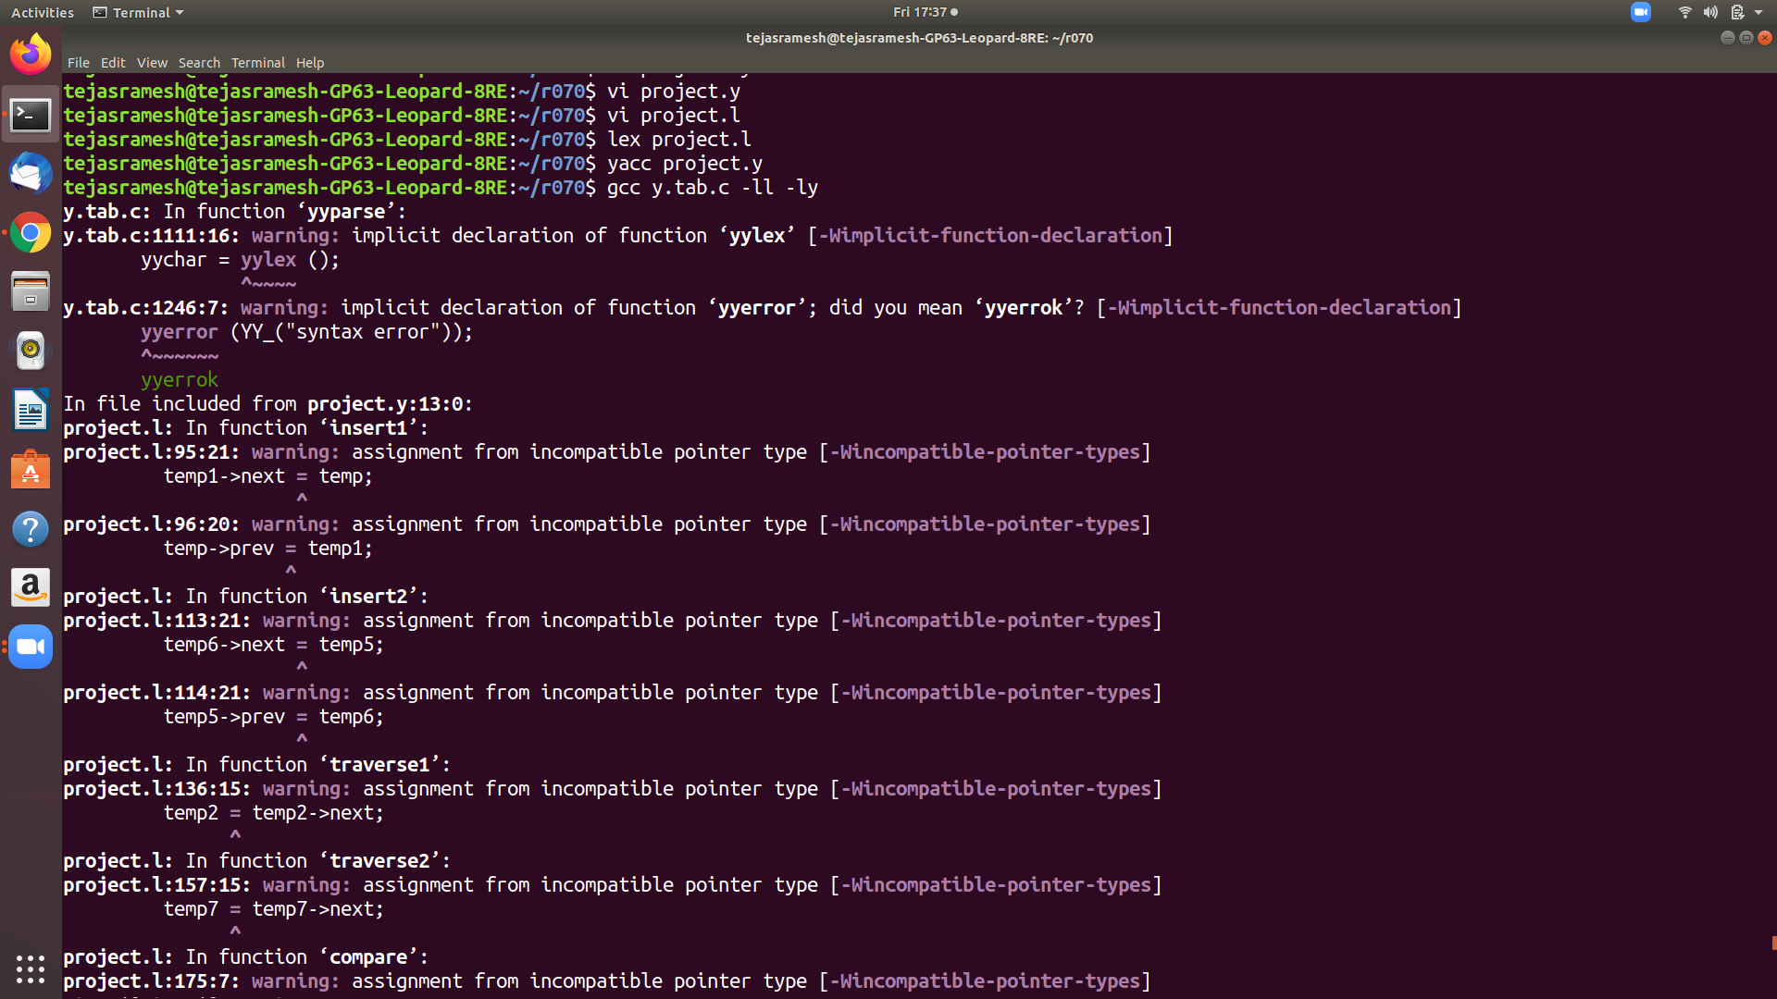 **COMPILING**

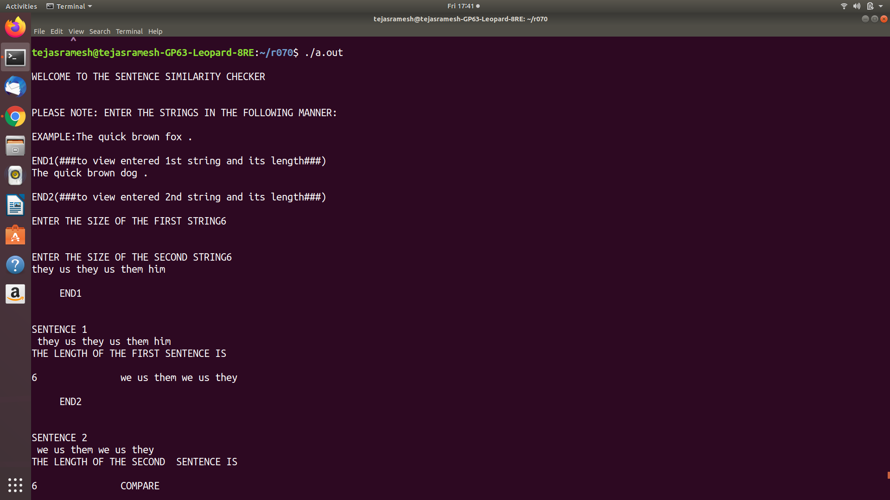**RUNNING THE CODE FOR DISSIMILAR STRINGS**

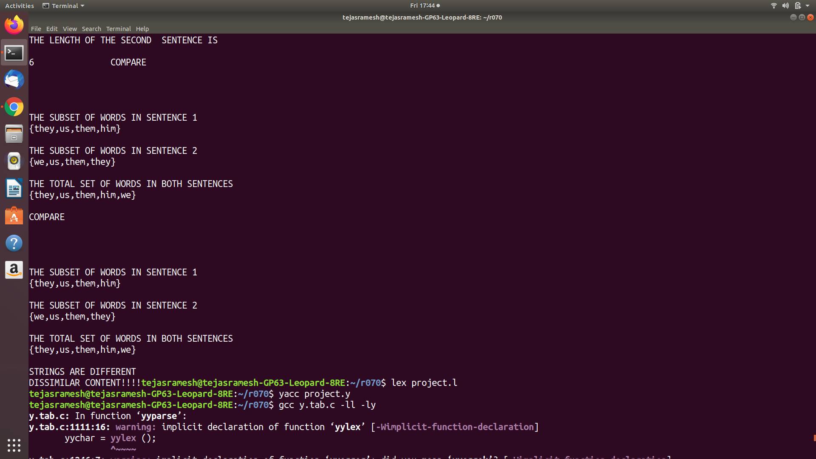

**OUTPUT 1-(FOR DIFFERENT STRINGS)**

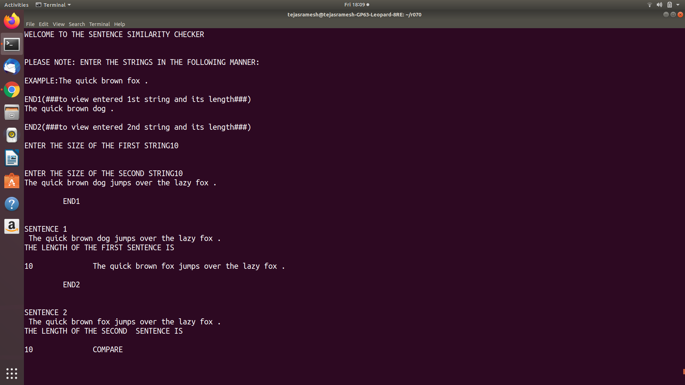**RUNNING THE CODE FOR SIMILAR STRINGS.**

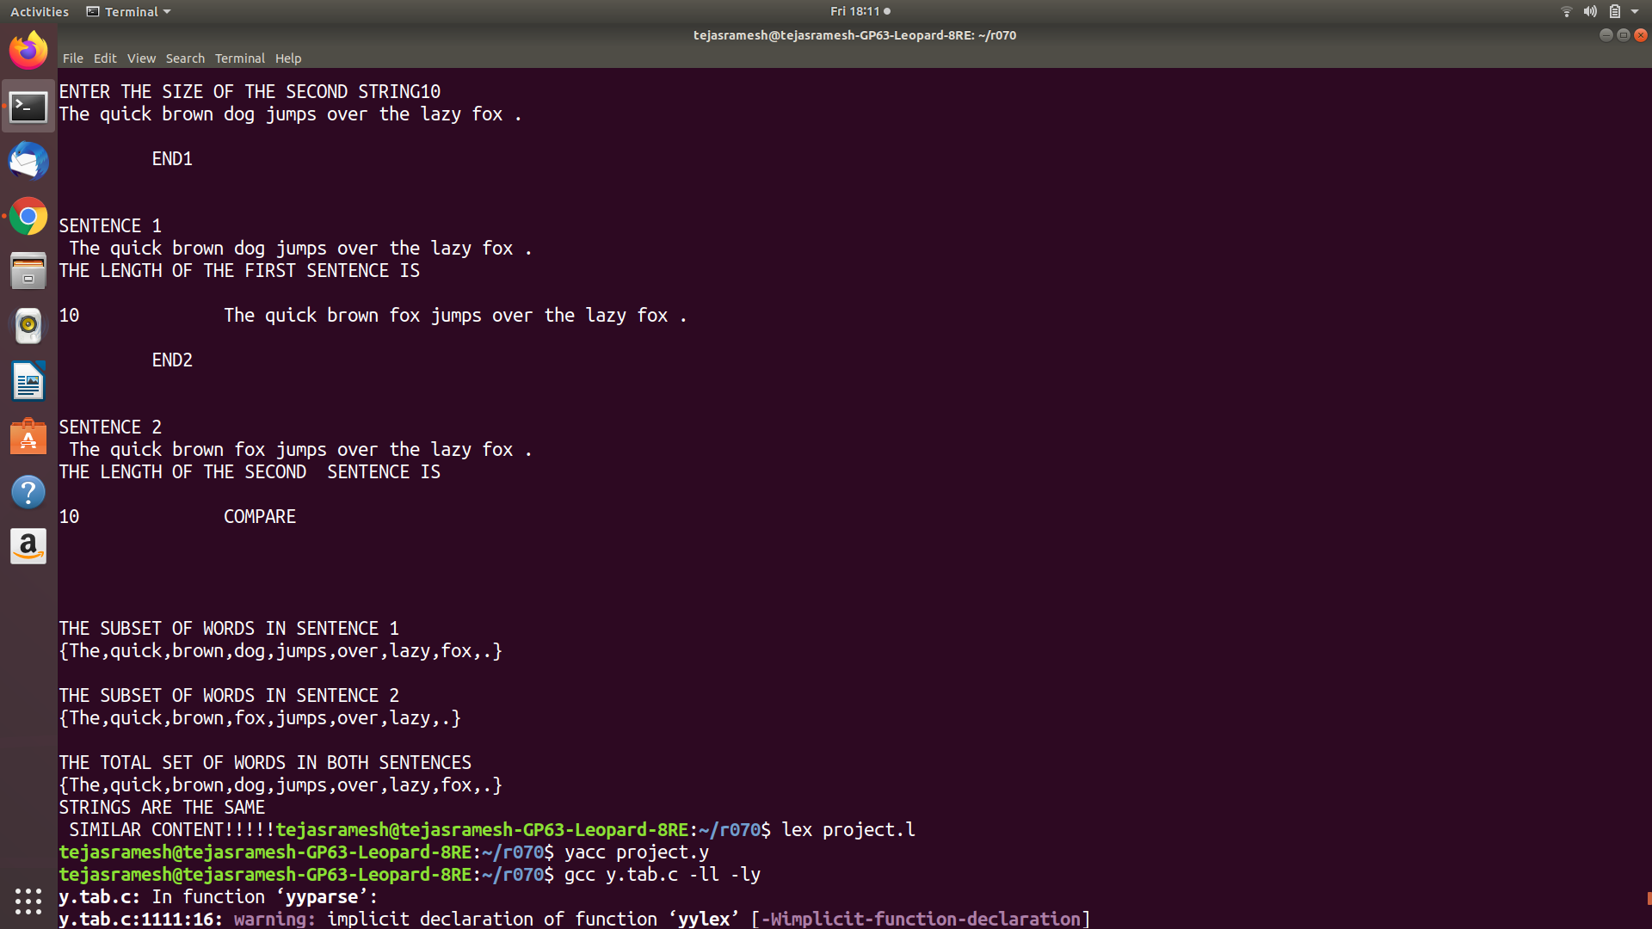**OUTPUT 2-(FOR DISSIMILAR STRINGS)**

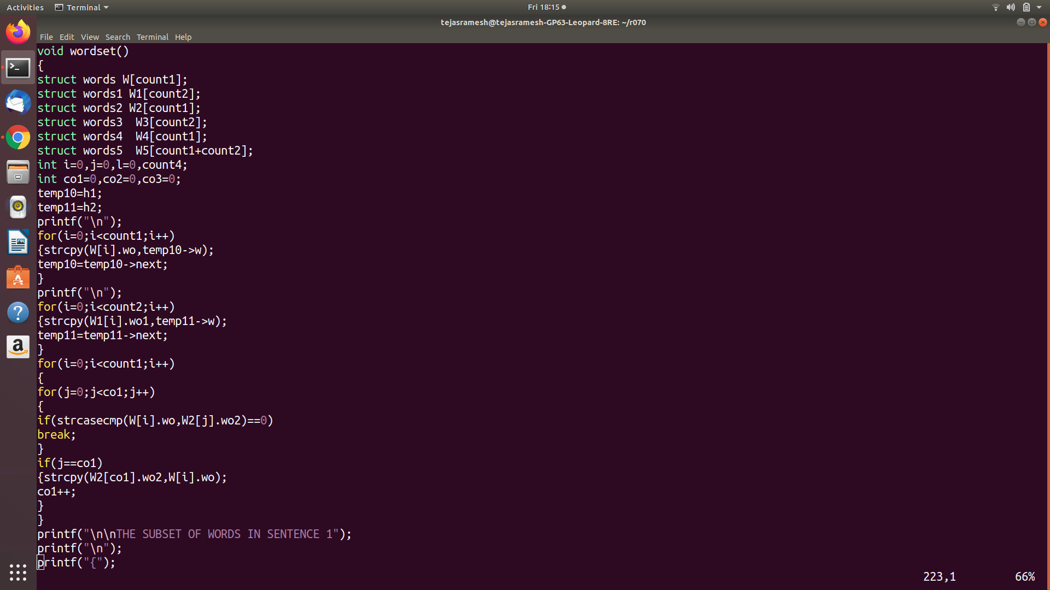**SAMPLE CODE SNIPPET 1**

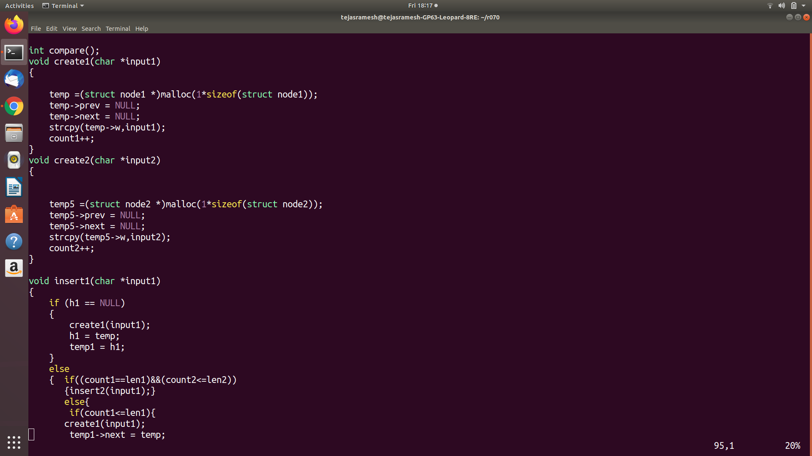

**SAMPLE CODE SNIPPET 2**

**SAMPLE OUTPUT SNAPSHOTS** **(PYTHON-JUPYTER NOTEBOOK IMPLEMENTATION)**

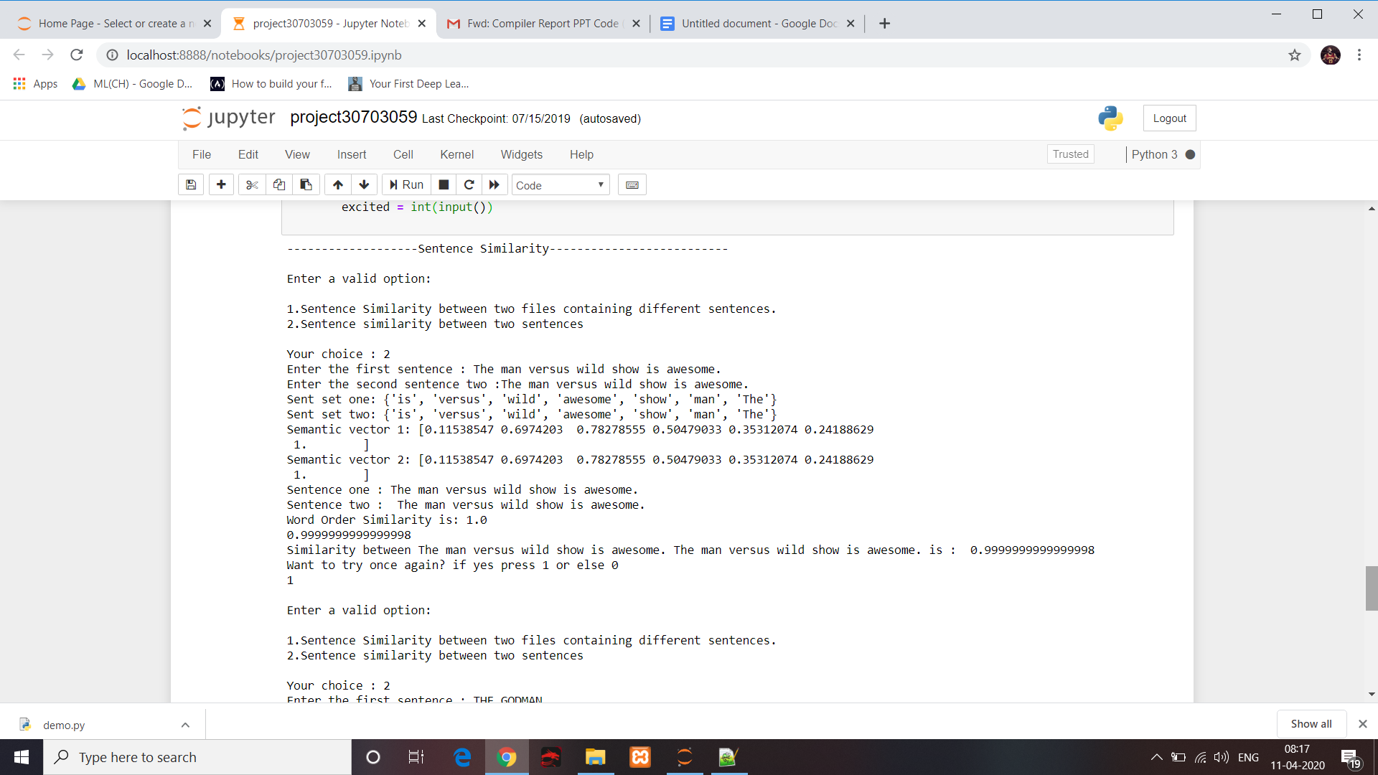

**OUTPUT FOR TYPED OUT SIMILAR SENTENCES.**

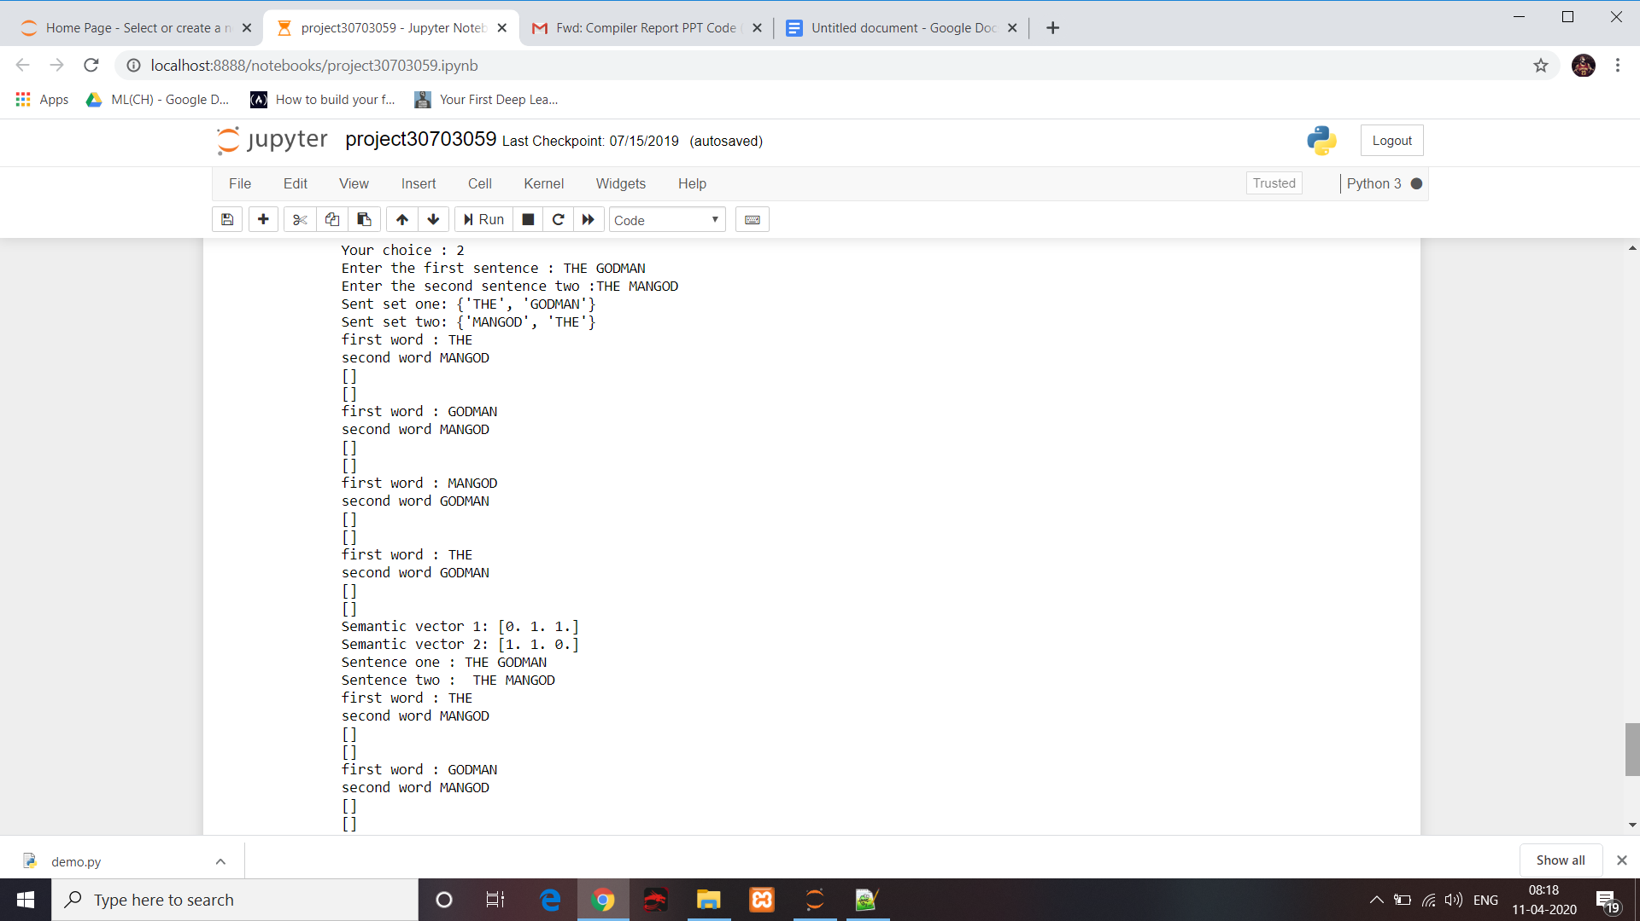

**OUTPUT FOR TYPED OUT DIFFERENT SENTENCES.**

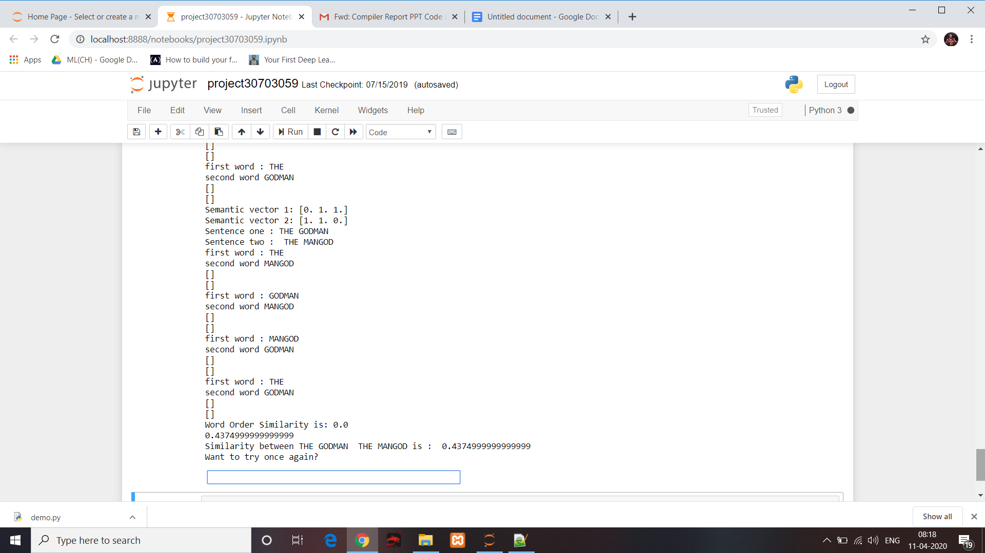

**OUTPUT FOR TYPED OUT DIFFERENT SENTENCES.**

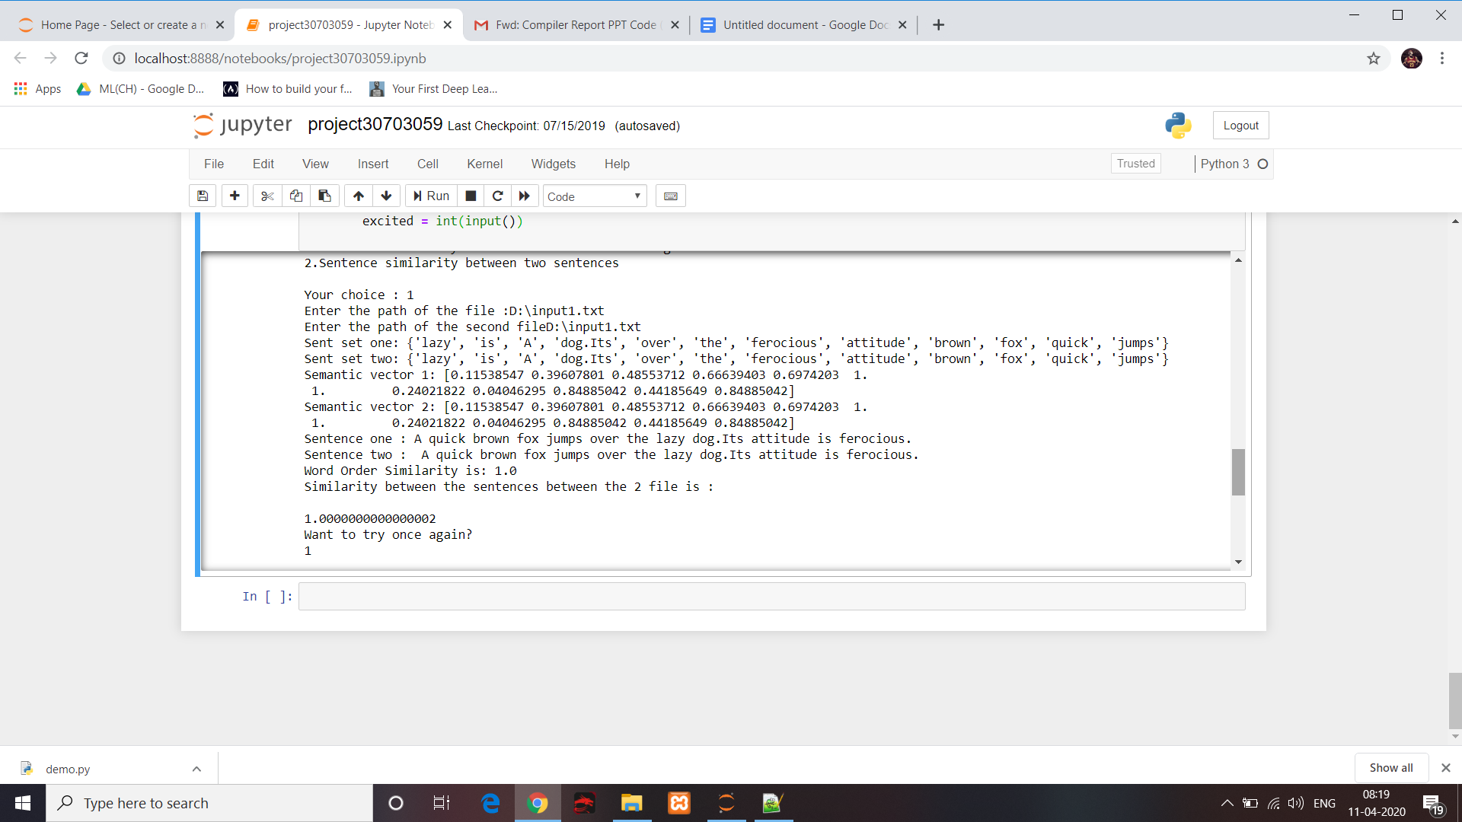

**OUTPUT FOR SAME INPUT FILE GIVEN TWICE (SIMILAR INPUT)**

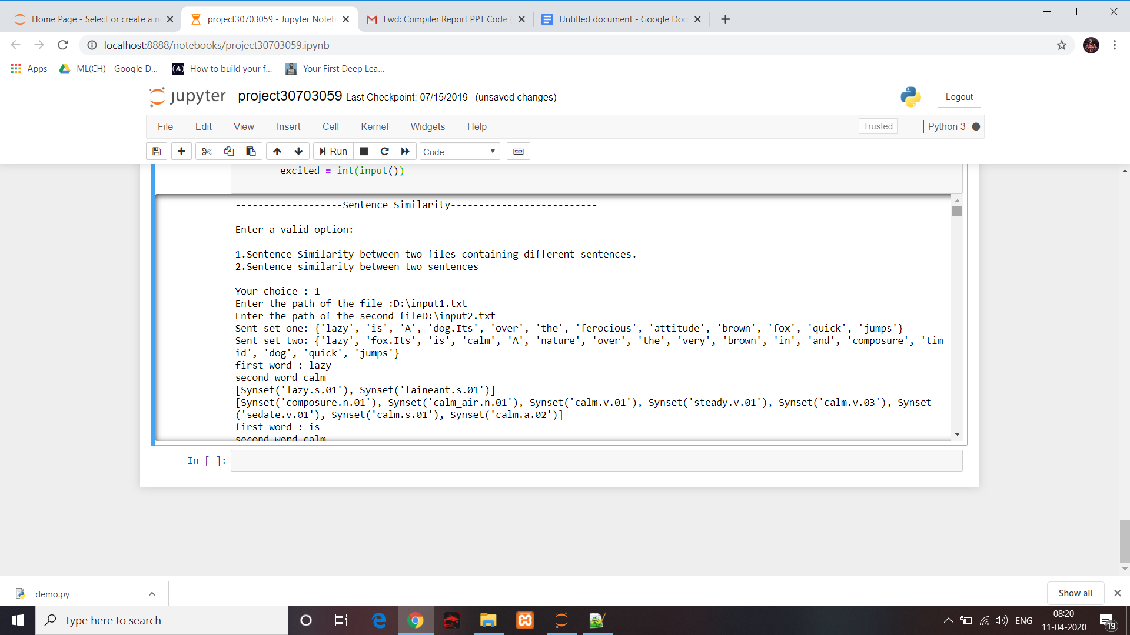

**OUTPUT FOR DIFFERENT INPUT FILES.**

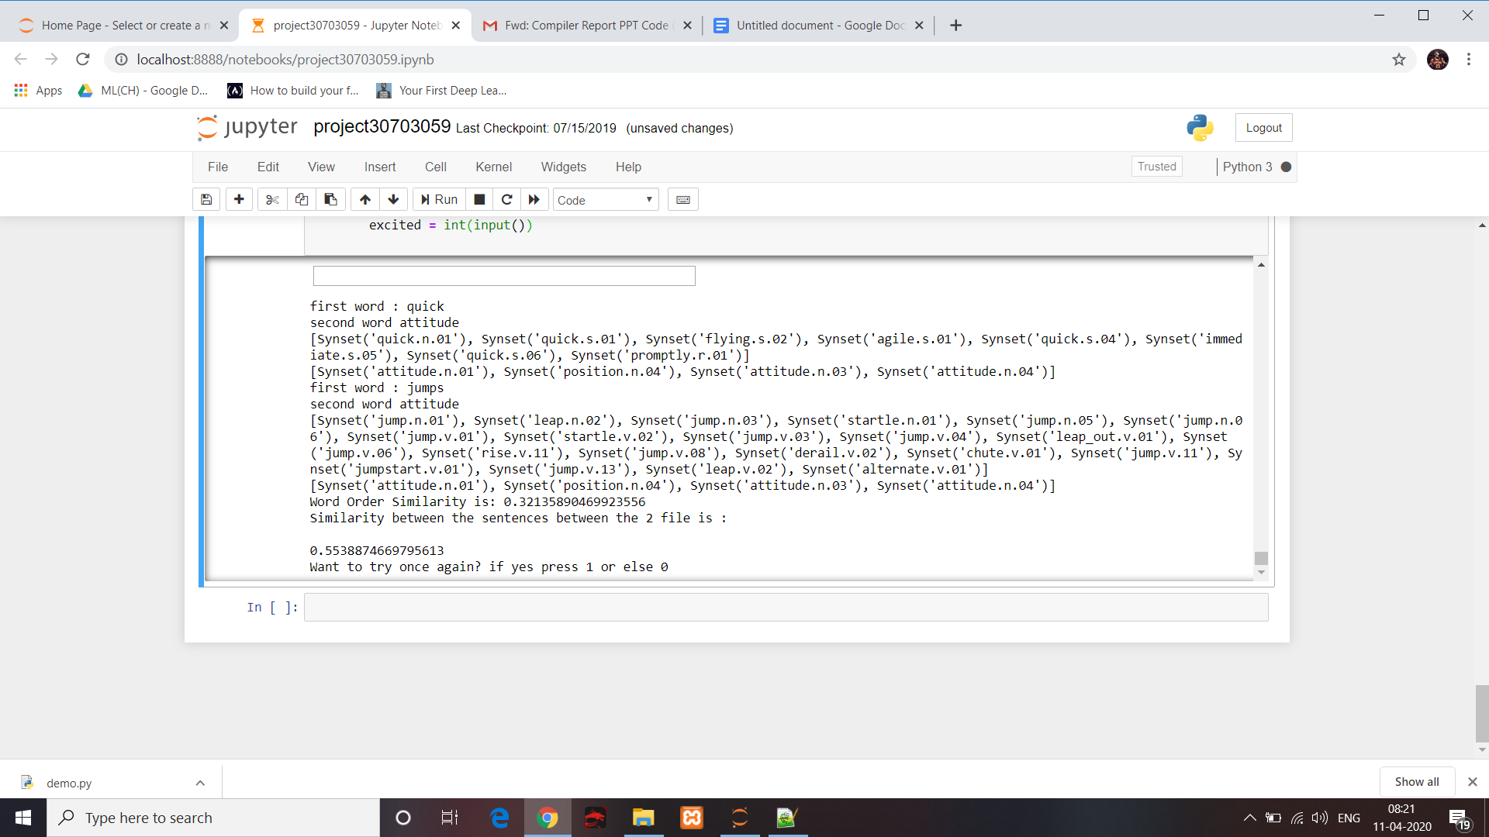

**OUTPUT FOR DIFFERENT INPUT FILES.**

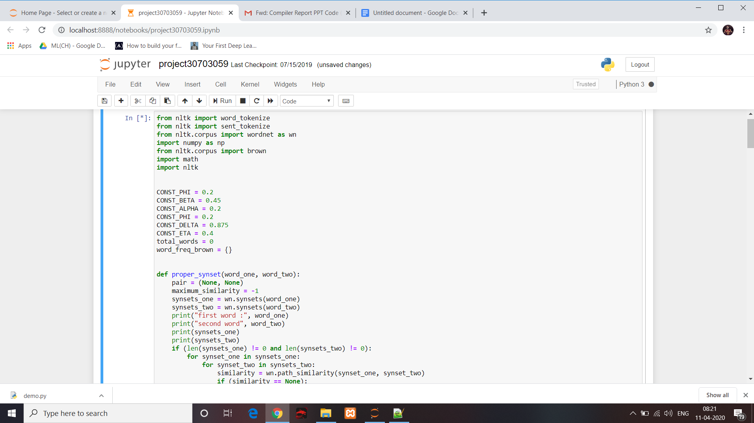

**CODE SNIPPET 1**

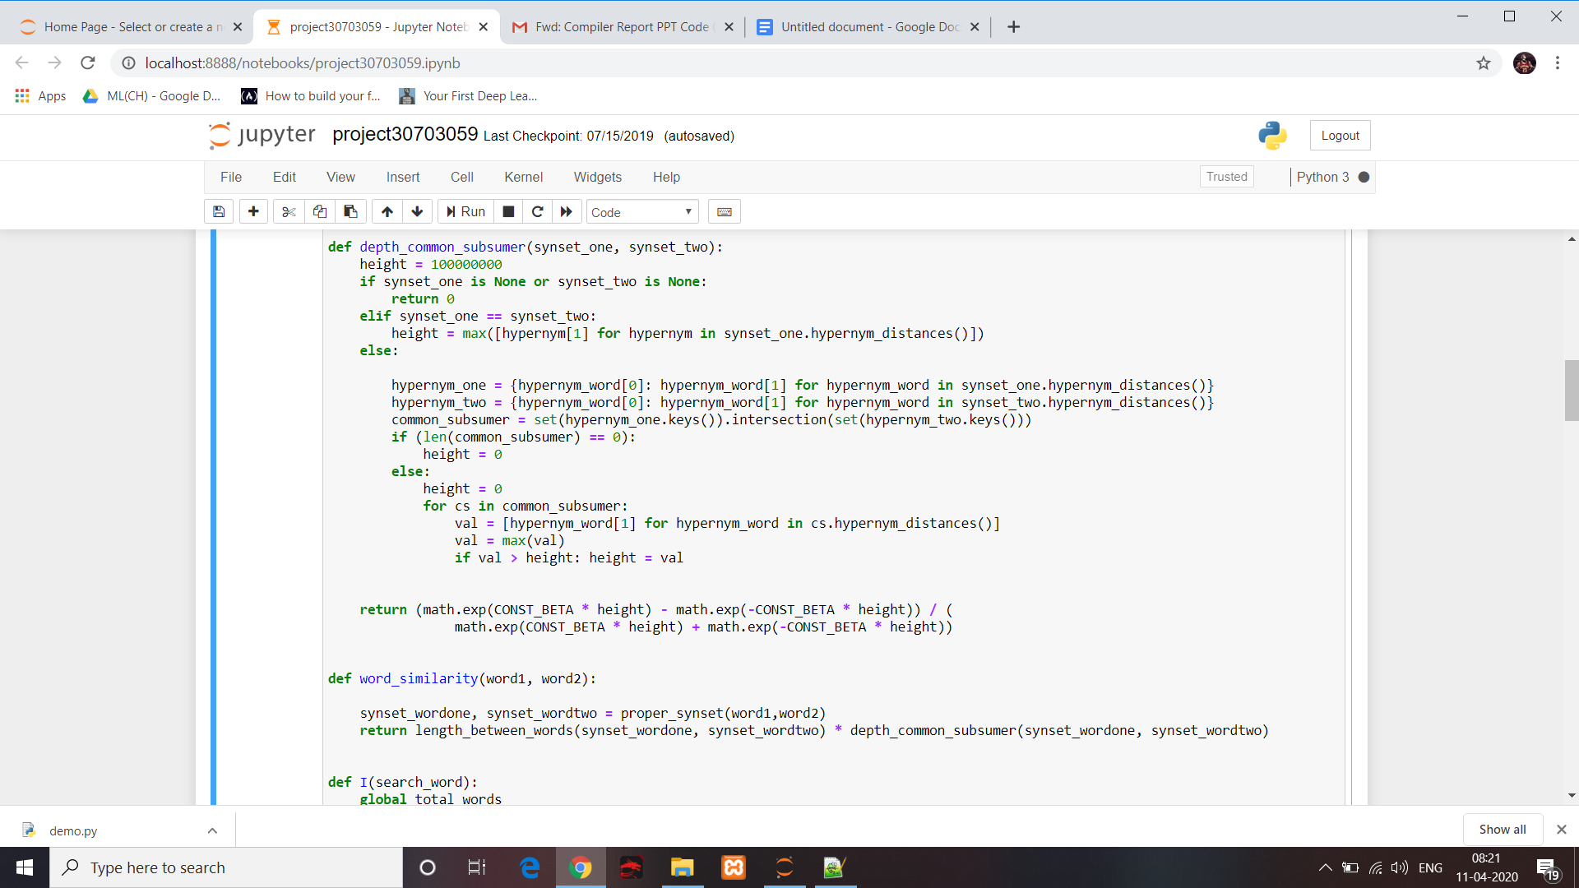

**CODE SNIPPET 2**